2013 PARLIAMENTARY BOUNDARY REVIEW

Submission by J.G.Harston
jgh@mdfs.net - mdfs.net/per13 – 28 September 2011
70 Camm Street, Walkley, Sheffield S6 3TR

The Boundary Commission for England have published their initial recommendations for new Parliamentary Constituencies in England. This is my recommendation for the 50 new Constituencies in the Yorkshire & Humberside region, and specifically within the area covered by Sheffield City Council. I am happy for anybody else to use the contents of this report.

1. The Boundary Commission’s initial proposal
1.1 The Boundary Commission’s initial proposal drastically breaks up communities, almost entirely ignores existing constituencies, ignores natural community groupings, geographic features and local authority boundaries, even subregional county boundaries. It has done this purely to place overwhelming insistence on not splitting local authority wards between constituencies.

2. Regional overview
2.1 Looking at the four subregions of Yorkshire & Humberside shows the following electoral entitlement:
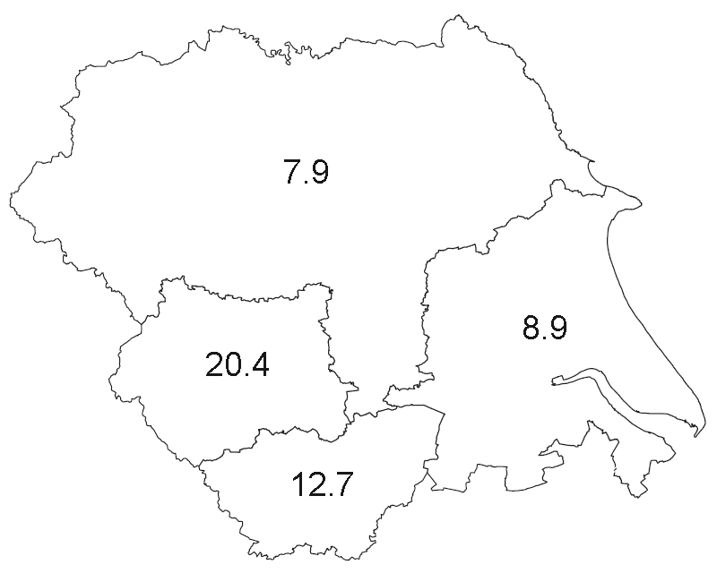 | Subregion | Electorate | Seats
 | North Yorkshire & York | 608,713 | 7.9
 | Humberside | 688,722 | 8.9
 | West Yorkshire | 1,577,088 | 20.4
 | South Yorkshire | 974,419 | 12.7

Map 1 : Subregional seat entitlements

2.2 The entitlements for North Yorkshire & York and for Humberside are near enough to whole numbers to round them up to 8 and 9 seats respectively. West Yorkshire and South Yorkshire have fractional entitlements, so should be dealt with together with a total entitlement of 33 seats.
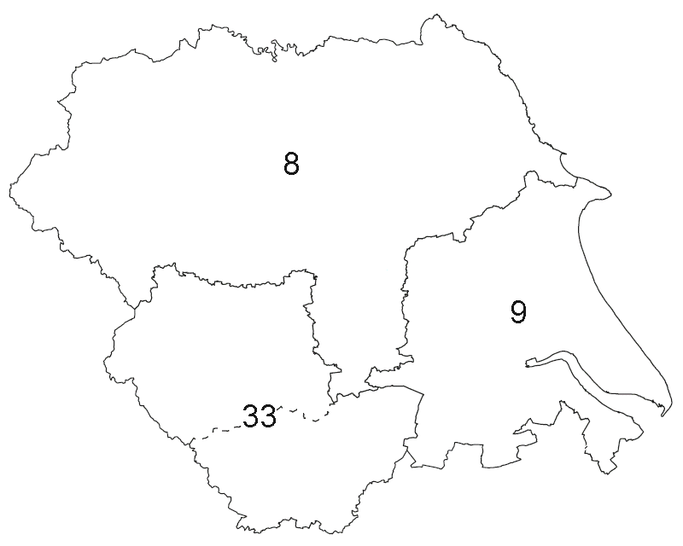 | Subregion | Electorate | Seats
 | North Yorkshire & York | 608,713 | 8
 | Humberside | 688,722 | 9
 | West & South Yorkshire | 2,551,507 | 33

Map 2 : Subregional rounded seat entitlements

2.3 Looking within South and West Yorkshire shows the following seat entitlements split up by local authority area:
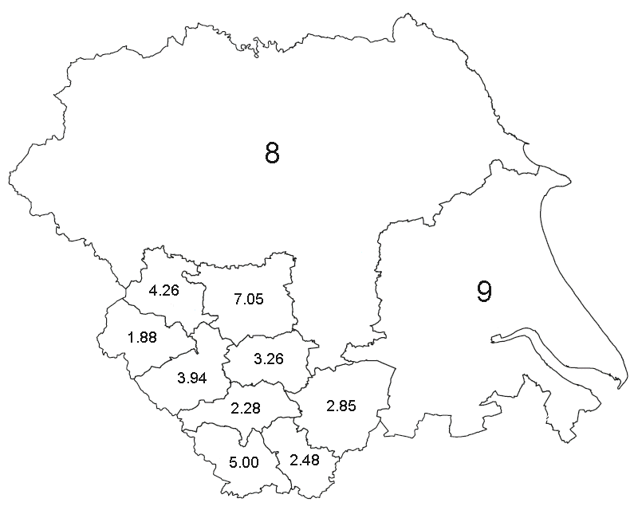 | District | Seats
 | Bradford | 4.26
 | Leeds | 7.05
 | Calderdale | 1.88
 | Kirklees | 3.94
 | Wakefield | 3.26
 | Barnsley | 2.28
 | Doncaster | 2.85
 | Sheffield | 5.00
 | Rotherham | 2.48

Map 3 : Seat entitlements with South & West Yorkshire

2.4 Consequently, with South & West Yorkshire I recommend that seats be drawn up as follows:
7 seats in Leeds
5 seats in Sheffield
21 seats covering Bradford, Calderdale, Kirklees, Wakefield, Barnsley, Doncaster, Rotherham
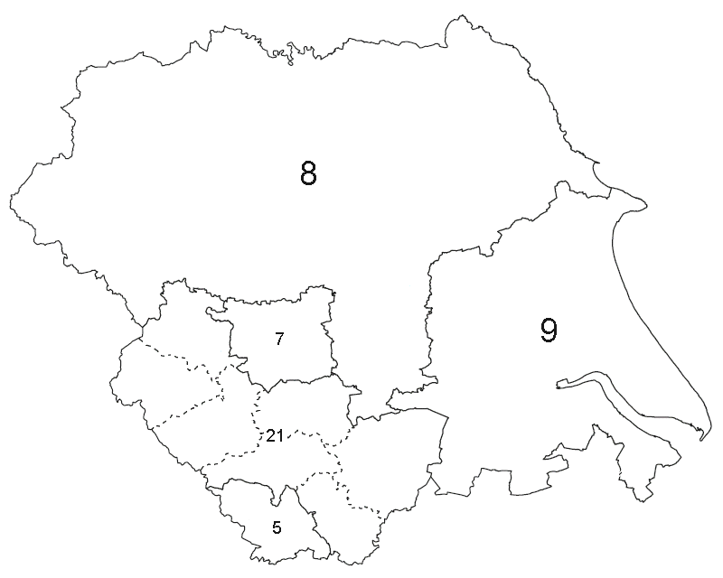 | District | Seats
 | Leeds | 7
 | Sheffield | 5
 | Bradford, Calderdale, Kirklees, Wakefield, Barnsley, Doncaster, Rotherham | 21

Map 3 : Seat entitlements with South & West Yorkshire

I observe that Bradford, Calderdale and Kirklees form a contiguous area with an entitlement of 10.08 seats. Consideration could be given to allocating exactly 10 seats to the area of Bradford, Calderdale and Kirkless and exactly 11 seats to the area of Wakefield, Barnsley, Doncaster and Rotherham.

3 Sheffield
3.1 The electoral quota for England is 76,641 electors; Sheffield’s electorate on the reference register (December 2011) is 386,512. This gives Sheffield an entitlement to 5.04 constituencies. Dividing the Yorkshire Region electorate of 3,848,942 by the 50 seats allocated to the region gives an average of 76,979, which gives Sheffield an entitlement to 5.02 constituencies. Dividing the electorate of South & West Yorkshire by the exactly 33 seats that I recommend gives an electorate average of 77,318, which gives Sheffield an entitlement of 5.00 seats. However you look at it, it would be sensible, then, to construct exactly 5 constituencies entirely within Sheffield. Indeed, it would be perverse not to.

3.2 Building exactly 5 constituencies entirely within Sheffield does not have knock-on effects to other parts of the region due to Sheffield being right in the south-west corner of the region, bordering another region on two sides. As will be described, the 28 wards of Sheffield can be arranges into 5 equal groupings with only two wards split in a minimal and sensible manner.

4 Jonathan Jordan proposal
4.1 In a posting on the Sheffield Forum Jonathan Jordan (user JHJ21) proposed a model for Sheffield which I believe is the strongest model for Sheffield and the best fit to the communites and natural geography [http://www.sheffieldforum.co.uk/showthread.php?p=8070998]. It also has minimal departures and changes from the historic constituencies found within Sheffield over the past 150 years. This is the model I recommend for Sheffield.

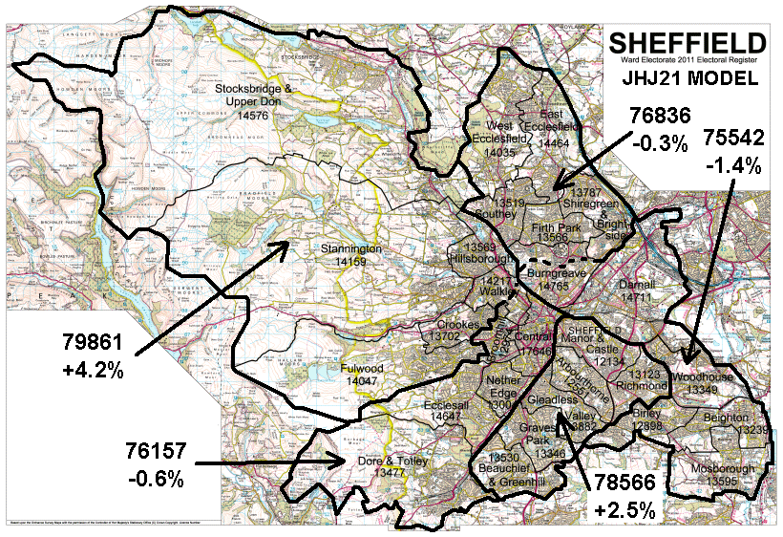

Map 4 : Jonathan Jordan’s model for Sheffield Parliamentary Constituencies

4.2 As Dr Jordan explains, Sheffield naturally falls into areas bounded by the river valleys along the Don and the Sheaf. This naturally groups two constituencies’ electorate in the west of the city and three constituencies’ electorate in the east. Due to the electorate of the wards surrounding the city centre having departed from the electoral average since they were drawn in 2004, only two wards need to be split to create the required five constituncies. The wards are also actually split along the line of the previous constituency boundaries prior to 2010. In the appendix I have included large-scale maps to show exactly where these two boundaries should be drawn.

4.3 Southey, Firth Park, Shiregreen & Brightside and the northern section of Burngreave formed the majority of the Brightside ward prior to 2010 have and formed the core of the Brightside constituency for well over 100 years, for its entire existence as a constituency. As pointed out by Mr David Blunket and others in representations to the 2005 review, Grenoside and Ecclesfield are natural northern extensions of the Brightside area [BCE 2005, rep. 30 and others]. Placing West Ecclesfield and East Ecclesfield wards together with Southey, Firth Park, Shiregreen & Brightside and the part of the Burngreave ward north of the pre-2010 constituency boundary creates a natural Brightside constituency, indeed a model strongly supported by many representations to the 2005 review [BCE 2005, rep 1-14 and others].

4.4 The actual recommended constituency boundary through Brungreave ward is a slightly tidied-up version of the pre-2010 boundary to take account of building developments since the boundary was originally drawn in the early 20th century and follows the line of Bagley Dyke from Little Roe Wood instead of the centre of the main road.

4.5 The remaining half of Burngreave ward, south of the pre-2010 counstituency boundary, naturally joins with the existing South-East constituency. Many representations to the 2005 review strongly supported a south-east constituency close to the pre-2010 boundaries, and the current constituency is very close to that. Mr Clive Betts and may others also strongly recommended that this constituency keep the historic name Attercliffe [BCE 2005, rep 29 et al].

4.6 The remaining six wards naturally group together bounded by the Sheaf and the Sheffield Parkway into Heeley constituency. The drop in the electorate of the Manor & Castle ward and the Arbourthorne ward mean that these whole wards have just the right total electorate for a whole constituency. As representation from Mrs Megg Munn and others pointed out, the pre-2010 and the current Heeley constituency is a very natural fit to the geography and communities of the area, and including the Manor & Castle ward completes it to form a new constituency.

4.7 In the west of the city, the Porter Valley is used as the main boundary to create constituencies. This is a clear and distinct boundary for almost all its length where used as a boundary between the Fullwood and Ecclesall wards. To form two constituencies in the west, one ward needs to be split. Fortunately, using the existing pre-2010 constituency boundary running through Walkley ward provides us with two constituencies of just the right numbers.

4.8 In the north-west, the Stocksbridge & Upper Don, Stannington and Hillsborough wards naturally fit together. Indeed, Hillsborough naturally flows out westwards into Stannington ward, and Stocksbridge & Upper Don ward is a natural rural hinterland of both Hillsborough and Stannington. Placing Stocksbridge & Upper Don ward and Stannington ward in the same constituency also ensures that Bradfield Parish Council is not split between two constituencies as it is now, a complaint raised by several representations to the 2005 review [BCE 2005, rep 7-14, et al].

4.9 Fulwood and Crookes wards naturally fit together, indeed in places around Sandygate it is difficult to tell that you have moved from one ward to another. The Crookes end of Crookes ward naturally runs down into Walkley, indeed the pre-2004 Walkley ward used to include 1/3 of Crookes. Together with the “greater Hillsborough” they naturally form a north-west constituency. The historic name for a constituency covering this area is Sheffield Hillsborough, but due to the old Upper Hallam and Nether Hallam townships covering the Fulwood/Crookes/Walkley area the name Sheffield Hillsborough & Hallam would also be appropriate.

4.10 Prior to 1950 there was a Sheffield Ecclesall constituency which was very close to the remaining south-west constituency in this model, and very close to the old Ecclesall Bierlow township. Dore & Totley, Ecclesall and Broomhill wards have often been in the same constituency and – before 1993 – Nether Edge with them. Due to ward boundary changes in 2004 Nether Edge, Broomhill and Central wards merge together around their boundaries and it makes a natural fit to put them together. The Upperthorpe and Netherthorpe parts of Walkley Ward were in the pre-2010 Central constituency along with Nether Edge ward, Central ward and about half of the Broomhill ward.

4.11 The resultant constituencies, and their recommended names, can be described as:
Attercliffe: the old (pre-2010) Attercliffe plus Burngreave
Brightside: The old Brightside plus Chapeltown/Ecclesfield
Heeley: the old Heeley plus Manor/Castle
Ecclesall: the old Hallam with Nether Edge/Central instead of Crookes/Fulwood
Hillsborough: the old Hillsborough with Crookes/Fulwood instead of Chapeltown/Ecclesfield

5. Rivelin Valley proposal
5.1 When initially drafting a model for Sheffield I looked for a model that would use the Rivelin Valley as a boundary. The Rivelin is a strong boundary between Stannington ward and Fulwood ward and prior to 1974 was the City Council boundary. Consequently, I looked at Dr Jordan’s proposal to see if a workable modifcation could be made that used the Rivelin as a boundary.

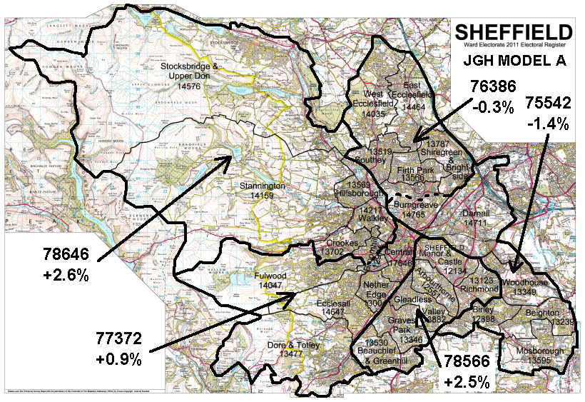

Map 5 : Jonathan Harston model for Sheffield Parliamentary Constituencies

5.2 This differs from the Jordan model in that the Fulwood ward is swapped from the North-West to the South West constituency, balanced by a split Broomhill ward replacing a split Walkley ward. The only advantage this model has over the Jordan model is that it uses the Rivelin as a boundary. In all other aspects, the Jordan model is the stronger. If having the Rivelin Valley as a constituency boundary is strongly supported, then this model should be used, otherwise the Jordan model is the stronger on all counts.

6. North Yorkshire & Yorkshire
6.1 North Yorkshire & York have an electorate that entitles it to close enough to 8 seats to have exactly 8 seats. There are currently 8 seats in North Yorkshire & York, and all of them already have electorates within +/-5% of the new electoral quota. Consequently, I recommend that the eight seats in North Yorkshire & York be left unchanged, as follows:
Seat Divergence
Harrogate & Knarsborough –2.08%
Richmond +2.95%
Scarborough & Whitby –0.73%
Selby & Ainsty –3.99%
Skipton & Ripon +0.60%
Thirsk & Malton +0.77%
York Outer –1.29%
York Inner –1.98%

7. Humberside
7.1 I make no recommendations for Humberside other than it should be organised into exactly 9 seats.

8. Summary for Sheffield

Sheffield Attercliffe | Beighton | 13239
 | Birley | 12898
 | 1/2 Burngreave | 7750
 | Darnall | 14711
 | Mosborough | 13595
 | Woodhouse | 13349
 |  | 75542 | -1.4%
Sheffield Brightside | 1/2 Burngreave | 7015
 | East Ecclesfield | 14464
 | Firth Park | 13566
 | Shiregreen & Brightside | 13787
 | Southey | 13519
 | West Ecclesfield | 14035
 |  | 76836 | -0.3%
Sheffield Ecclesall | Broomhill | 12974
 | Central | 17646
 | Dore & Totley | 13477
 | Ecclesall | 14647
 | Nether Edge | 13004
 | 1/3 Walkley | 4409
 |  | 76157 | -0.6%
Sheffield Heeley | Arbourthorne | 12551
 | Beauchief & Greenhill | 13530
 | Gleadless Valley | 13882
 | Graves Park | 13346
 | Manor & Castle | 12134
 | Richmond | 13123
 |  | 78566 | +2.5%
Sheffield Hillsborough | Crookes | 13702
 | Fulwood | 14047
 | Hillsborough | 13569
 | Stannington | 14159
 | Stocksbridge & Upper Don | 14576
 | 2/3 Walkley | 9808
 |  | 79861 | +4.2%

9. About the author
I have extensive experience in mapping and mapmaking, particularly within Sheffield. I have submitted reports to the previous Parliamentary and Local boundary reviews. I was formerly a City Councillor for 11 years. This is a personal report and has not been commissioned by any other person or grouping, though I am happy for anybody to adopt it as their recommendation.
Jonathan Jordan proposal
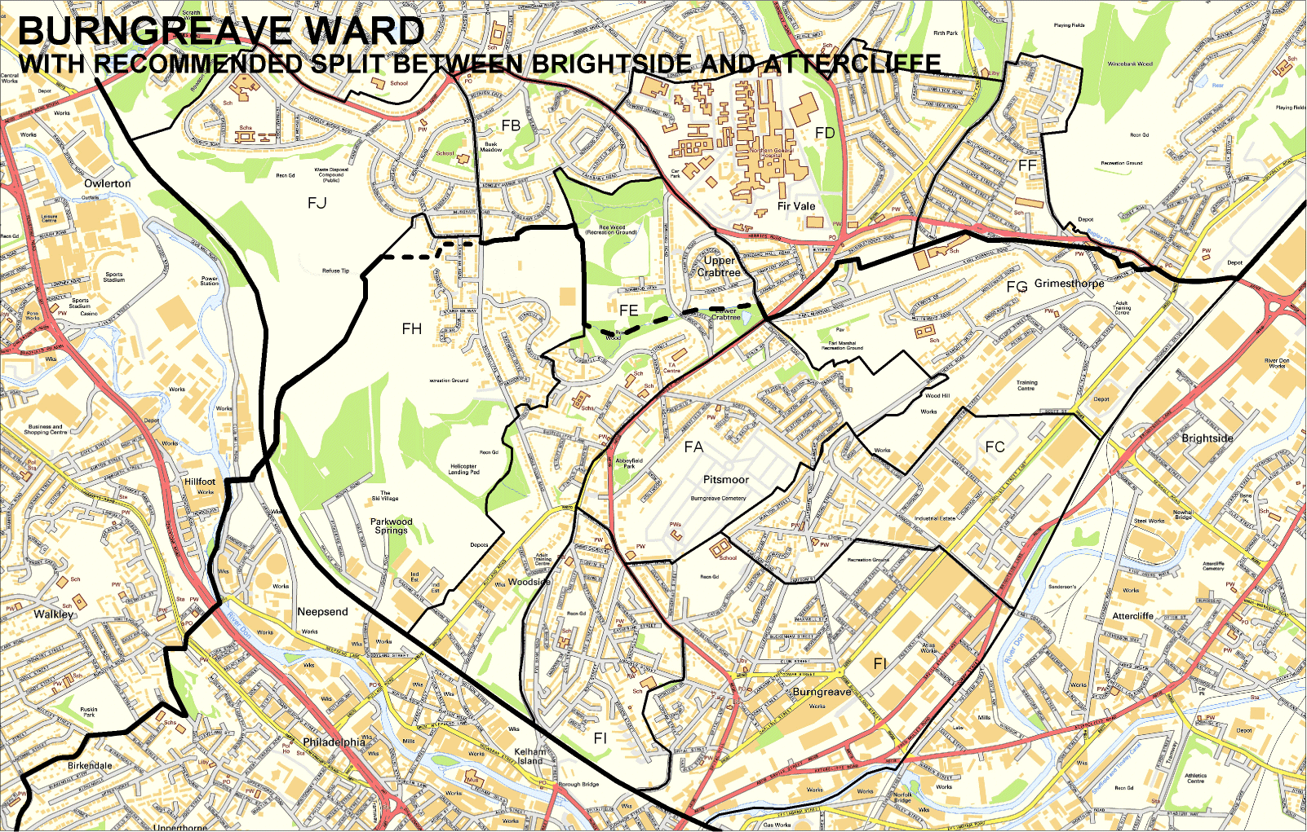
Recommended split of Burngreave Ward
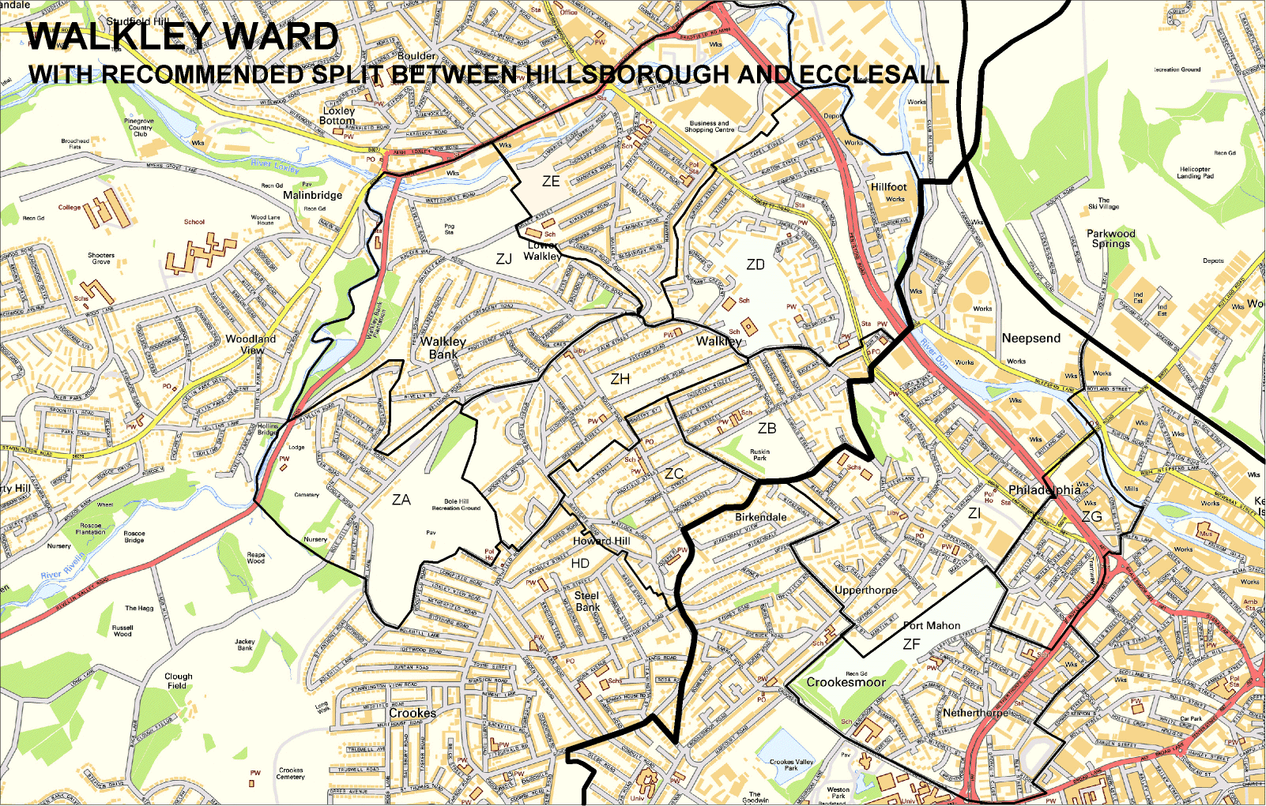
Recommended split of Walkley Ward in JHJordan model
Jonathan Harston ‘Rivelin’ proposal
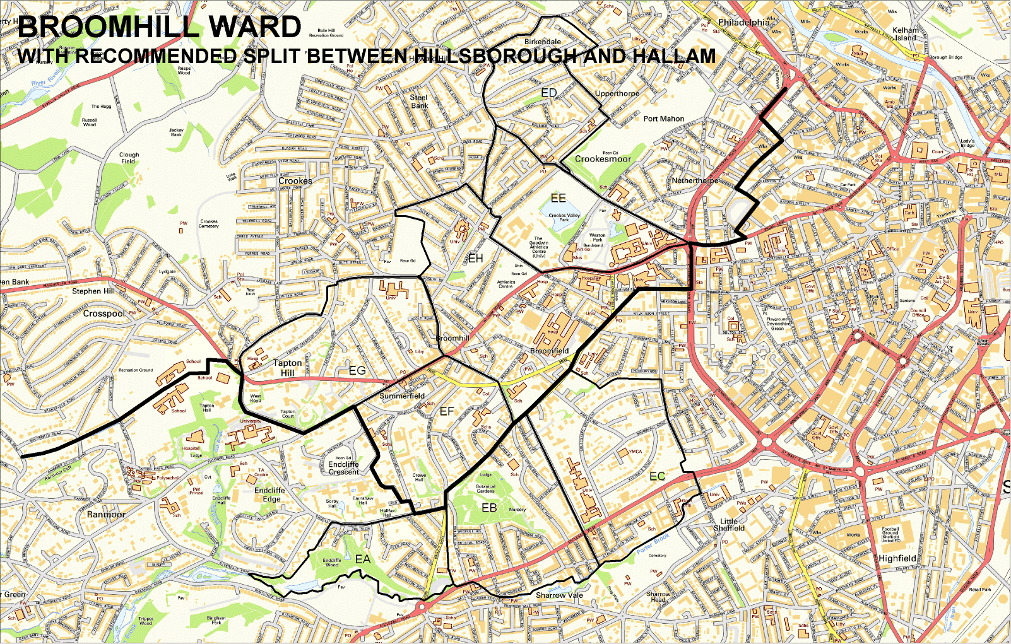
Recommended split of Broomhill Ward in JGHarston ‘Rivelin’ model

