ADFS on the BBC Master
To use the IDE hard drive interface with ADFS, you will need to disable the internal ADFS and enable the replacement ADFS. Enter the following commands:

*UNPLUG 13
*CONFIGURE FILE <r> where <r> is the ROM slot of the replacement ADFS
*CONFIGURE HARD to select hard drive :0 on poweron,
or *CONFIGURE FLOPPY to select floppy drive :4 on poweron

Turn the computer off for a couple of seconds, and then turn it back on again.

If you were supplied with a hard drive it will have already been initialised and some utility programs copied onto it in the $.Utils directory. You will also have a floppy disk with these programs on. The most important program is $.Utils.HDInit used to initialise a blank hard drive.

Initialisation
To initialise a blank hard drive run $.Utils.HDInit. Select the drive with option 'D', then select format with option 'F'. HDInit will examine the drive to find how big it is. It will display the size found and ask for confirmation before blanking it out. Enter YES to confirm. IMPORTANT ALL DATA ON THE DRIVE WILL BE WIPED BY THIS OPERATION!

Drive Numbers
With a hard drive present and turned on ADFS has the following drive mapping:

:0 First 512M of first IDE drive :4 First floppy drive
:1 Second 512M of first IDE drive :5 Second floppy drive
:2 First 512M of second IDE drive :6 Reserved
:3 Second 512M of second IDE drive :7 Reserved

With all drives mapped to a single IDE device, ADFS has the following drive mapping:
:0 First 512M of first IDE drive :4 First floppy drive
:1 Second 512M of first IDE drive :5 Second floppy drive
:2 Third 512M of first IDE drive :6 Reserved
:3 Fourth 512M of first IDE drive :7 Reserved

HADFS on the Master and BBC
HADFS version 5.30 can access IDE drives with the drives partitioned into 16M logical drives. HADFS
version 6 access drives in partitions up to 4G in size.

Initialisation
To initialise a blank hard drive run $.Utils.HDInit on the HADFS System disk. Select the drive with option 'D', then select format with option 'F'. HDInit will examine the drive to find how big it is. It will display the size found and ask for confirmation before blanking it out. Enter YES to confirm. IMPORTANT ALL DATA ON THE DRIVE WILL BE WIPED BY THIS OPERATION!

HDInit will also alow you to set up a hard drive with both an ADFS and an HADFS partition on it. The smaller partition is usually at the start of the disk, with the larger partition occupying the rest of the disk.

With HADFS version 5 the HADFS partition can be up to 16M and is usually at the start of the disk. With HADFS version 6 the HADFS partition can be up to 4G and is usually at the end of the disk.

Drive Numbers
With a hard drive present and turned on HADFS has the following drive mapping:

HADFS Version 5:
:4 First 16M of first IDE drive :8 First 16M of second IDE drive
:5 Second 16M of first IDE drive :9 Second 16M of second IDE drive
:6 Third 16M of first IDE drive :A Third 16M of second IDE drive
:7 Fourth 16M of first IDE drive :B Fourth 16M of second IDE drive

HADFS Version 6:
:4 First 4G of first IDE drive :8 First 4G of second IDE drive
:5 Second 4G of first IDE drive :9 Second 4G of second IDE drive
:6 Third 4G of first IDE drive :A Third 4G of second IDE drive
:7 Fourth 4G of first IDE drive :B Fourth 4G of second IDE drive

BBC 8Bit IDE Interface
SelfAssembly Guide

Parts Supplied
You should check that you have been supplied with the following parts for the selfassembly kit. These are the parts you need to obtain if you have only have the PCB, or you have made the PCB yourself, or are building the interface on stripboard. The connecting leads may be supplied already made up.
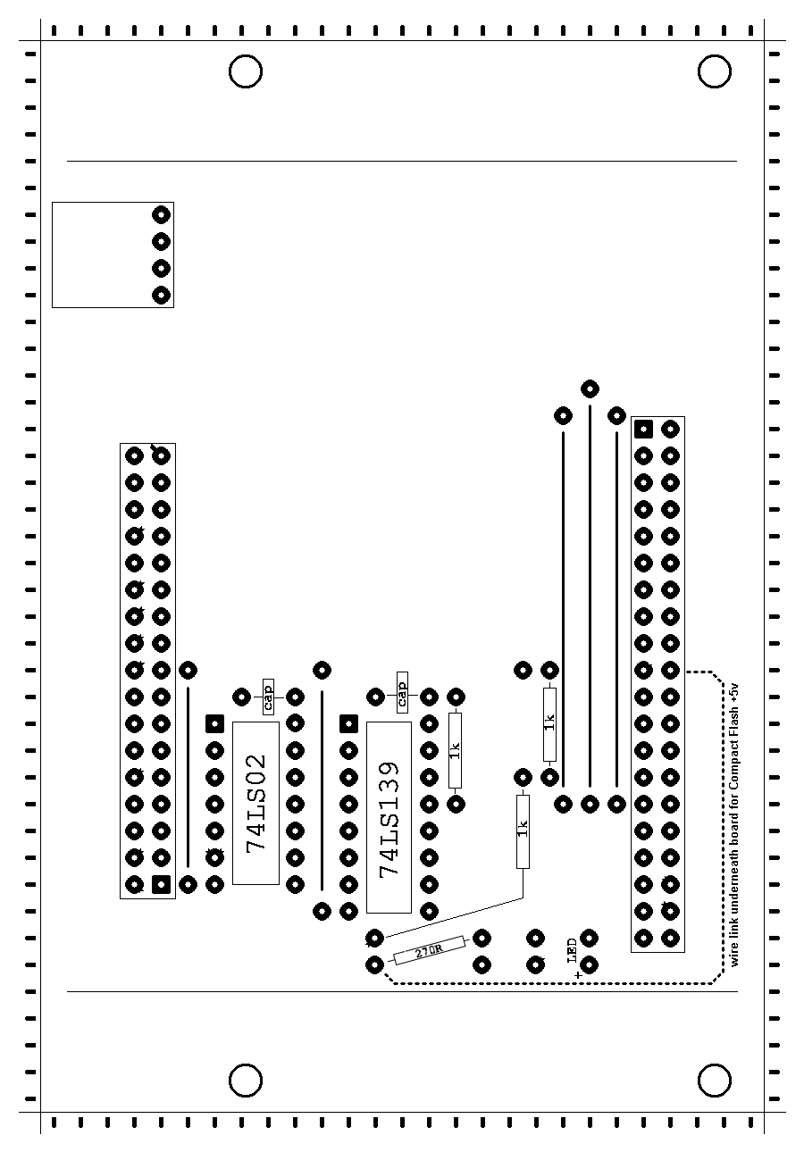

1 x 8Bit PCB BBC 8Bit IDE PCB
1 x plastic sheet spacer between PCB and ribbon cable
3 x 1K 5% resistor
1 x 270R 5% resistor
2 x 47nF radial ceramic capacitor
1 x 14pin IC socket
1 x 16pin IC socket
1 x 74HCT02 Quadruple 2Input PositiveNOR Buffer
1 x 74HCT139 2 to 4 line address decoder
1 x LED LED
1 x IDC hdr 1x4 0.1 pitch header right angled
1 x IDC hdr 2x17 0.1 pitch header
1 x IDC con 20x2 Male 20x2 IDC connector
4 x M6 screws fixing screws
1 x 40way cable IDE cable
5 x wire links
70cm x 34way cable 1MHz ribbon cable
2 x 34way IDC plug 1MHz cable plugs
1 x BBC power BBC power plug
1 x 5.25" power 5.25" drive power connector
1 x 3.5" power 3.5" drive power connector
70cm x 3way cable power cable

You will also need the following: PCB layout
1 x layout diagram
1 x ADFS 1.33 or ADFS 1.53 ROM or HADFS ROM
1 x Utils disk

Board Assembly
Assemble the board in the following order. When all components have been fitted there will be four unused holes in the PCB.

1: Three long wire links and two short wire links
2: Three short resistors and one long resistor
3: Power connector
4: IC sockets
5: IDC sockets: The fit between the 40-pin IDE socket and the wire link next to it is very tight. You may have to file down the edge of the socket to get a better fit. Connect a wire link on the underside of the PCB from pin 20 to +5v if you want to supply +5v to a Compact Flash device.
6: Capacitors
7: LED
8: Plug in the two ICs

Cable Assembly
Crimp the 34way plugs to each end of the 34way cable, ensuring pin one is at the same side at each end. Wire up the power cable with the BBC plug at one end and the 3.5" and 5.25" connectors at the other end.

Drive assembly
Plug the IDE data cable into the hard drive and the IDE card. Make sure the red line aligns with the same side of the socket at each end. Plug the 1MHz cable into the IDE card.

Plug the 5.25" power connector into the hard drive and the 3.5" power connector into the IDE card. The
power connector plugs in with the recessed side downwards, the red wire on the right, looking at the edge of the PCB.

With the hard drive upside down, fold the IDE cable under the IDE card and place the card on top of the hard drive, lining up the mounting holes. Place the insulating sheet between the PCB and the ribbon cable. Screw the card to the drive with the supplied screws.
Technical Information

Circuit Diagram

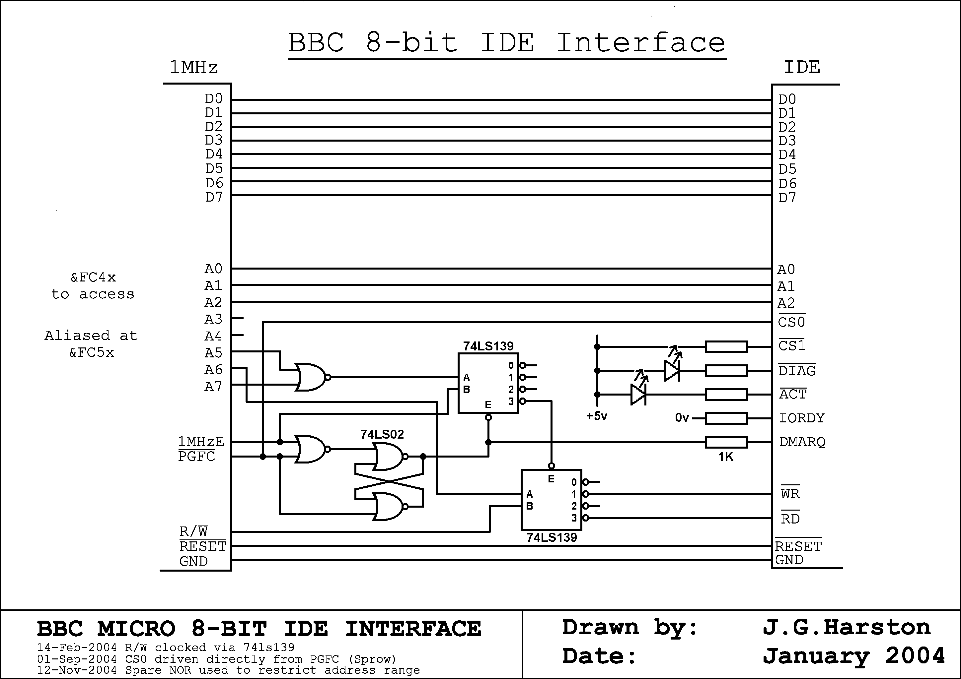

Sector Mapping

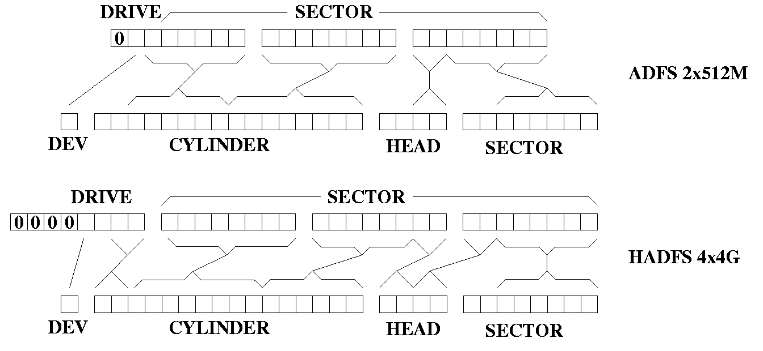

BBC 8Bit IDE Interface

User Guide

If not already done, plug the IDE data cable into the hard drive and the IDE card. Make sure the red line
aligns with the same side of the socket at each end. Plug the 1MHz cable into the IDE card. Plug the
5.25" power connector into the hard drive and the 3.5" power connector into the IDE card. The power
connector plugs in with the recessed side downwards, the red wire on the right.

With the hard drive upside down, fold the IDE cable under the IDE card and place the card on top of the
hard drive, lining up the mounting holes. Place the insulating sheet between the PCB and the ribbon
cable. Screw the card to the drive with the supplied screws.

Plug the 1MHz cable into the BBC/Master 1MHz connector. Plug the power connector into the
BBC/Master auxiliary power socket. The leads are long enough to wrap under the computer and over the back of the case so that the drive can sit on top of the computer.

You can use up to two IDE drives with the 8bit IDE card using an IDE cable with two plugs at the drive end, giving access to up to 2G of storage with ADFS or 8G with HADFS. The first drive must have it's drive ID link or Drive Select link set to C, A or 0. The second drive must have it's ID set to D, B or 1.

You can use the IDE interface with ADFS on the Master or HADFS on the Master or the BBC B/B+.

Inserting ROMs on the BBC B
There are four sideways ROM sockets on the BBC B motherboard, in the bottom righthand corner. Two of the sockets usually have BASIC and DFS in. The ROM sockets are IC52, IC88, IC100 and IC101.

IC52 occupies ROM slot 12.
IC88 occupies ROM slot 13.
IC100 occupies ROM slot 14.
IC101 occupies ROM slot 15.

Inserting ROMs on the BBC B+
There are five sideways ROM sockets on the BBC B+ motherboard, in the top lefthand corner. Each
socket can take a 16K or 32K ROM, depending on its links. The sockets are IC68, IC62, IC57, IC44 and IC35.

IC68 occupies ROM banks 10 and 11, link 18 WEST for 16K, EAST for 32K.
IC62 occupies ROM banks 8 and 9, link 15 WEST for 16K, EAST for 32K.
IC57 occupies ROM banks 6 and 7, link 9 WEST for 16K, EAST for 32K.
IC44 occupies ROM banks 4 and 5, link 11 WEST for 16K, EAST for 32K.
IC35 occupies ROM banks 2 and 3, link 12 WEST for 16K, EAST for 32K.

Inserting ROMs on the Master
There are three ROM sockets on the Master motherboard. At the rear is the MOS+System ROM. In front of it are three sockets, IC37, IC27 and IC41.

IC37 occupies ROM banks 6 and 7, enabled by moving link 19 WEST, disabling RAM in banks 6 and 7.
IC27 occupies ROM bank 8.
IC41 occupies ROM banks 4 and 5, enabled by moving link 18 WEST, disabling RAM in banks 4 and 5.
The front ROM catridge socket is ROM slots 0 and 1, the rear cartridge socket is ROM slots 2 and 3.

Inserting ROMs on the Master Compact
There are four ROM sockets on the Compact motherboard, IC38, IC23, IC17 and IC29.

IC38 occupies ROM banks 0 and 1, enabled by moving link L11 SOUTH, disabling external ROMs on
the edge connector.
IC23 occupies ROM bank 2.
IC17 occupies ROM bank 3.
IC29 occupies ROM bank 8.

